***12 April:***

***1NT19IS135***

***SAHANA.V***

***C1 BATCH***

***CRUD OPERATIONS:***

* ***Update operations modify existing documents in a collection***
* ***Some update operators, such as $set, will create the field if the field does not exist.***
* ***UPDATE ONE: Updates only one record at a time.***
* ***SYNTAX: db.database_name.updateOne***

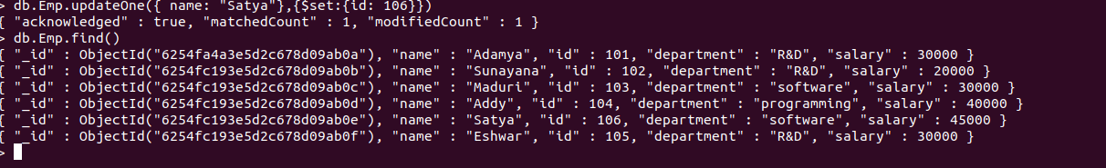

* ***UPDATE MANY:Updates only multiple record at a time.***
* ***SYNTAX: db.database_name.update***

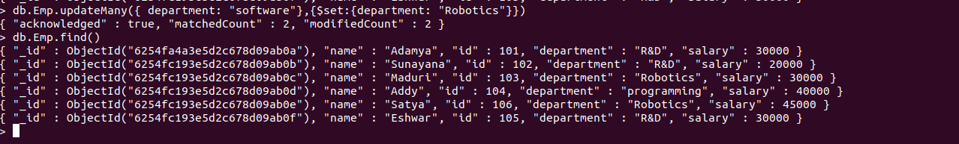

* ***REPLACE ONE: Replaces one record with other in a database.***
* ***SYNTAX: db.database_name.replaceOne***

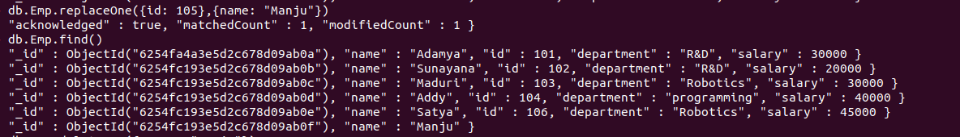

* ***DeleteOne() deletes the first document that matches the filter.***
* ***DELETE ONE:***
* ***SYNTAX: db.database_name.deleteOne***

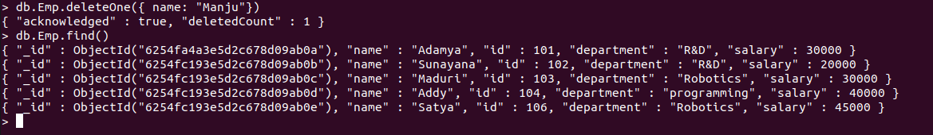

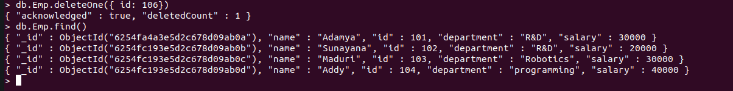

* ***Performing DELETE MANY operation:***

**SYNTAX: db.collection_name followed by deleteMany .**

**By using db.collection_name.find() getting deleted records.**



* ***UNSET:***
* ***$unset replaces the matching element with null rather than removing the matching element from the array***

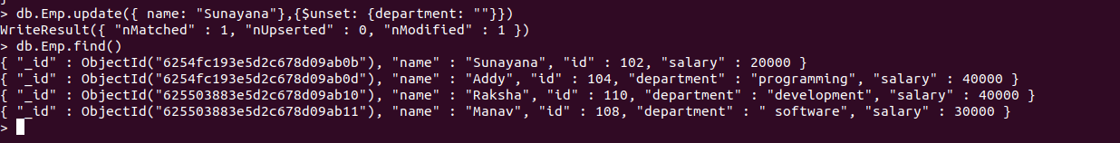

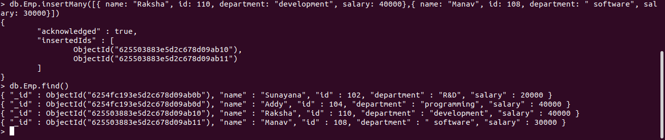

* ***LOGICAL AND:***

***Evaluates one or more expressions and returns true if all of the expressions are true or if run with no argument expressions. Otherwise, $and returns false .***



* **LOGICAL OR:**

***Evaluates one or more expressions and select or retrieve only those documents that match at least one of the given expression in the array***

